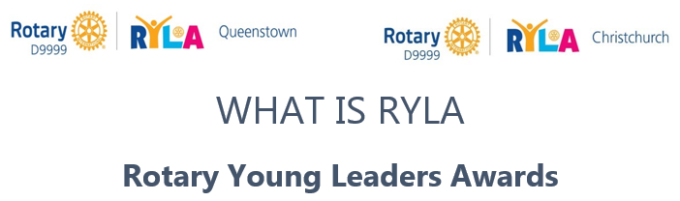

Information for Applicants
RYLA is a five-day residential high energy programme designed to further develop young leaders.
Rotary District 9999 runs two RYLA camps, one in Christchurch and one in Queenstown. You, the candidate can choose which camp suits you best based on dates, location, or age.

- RYLA Queenstown - 29th January – 3rd February 2023 at Lakeland Park Camp.
This camp is open for candidates 20-30 years old.
- RYLA Christchurch - 15-20th January 2023, at College House, Waimairi Road Christchurch.
This camp is open for candidates aged 18-25 years old.
You are responsible for getting yourself to and from the venue and to obtain the items on the equipment list.
Originating in 1959 in Queensland, this exciting programme engages Rotary clubs around the world every year to help the next generation of leaders expand their skills. The RYLA programme is an intensive, live-in camp, where participants are recognised as current and future adult leaders.
RYLA is very much about collaboration and enjoys substantial goodwill within the wider community, each year attracting cooperation from community and cultural organisations, business, as well as civic and national leaders. Each supporter understands the long-term benefits our young leaders gain from their RYLA experience.
RYLA is facilitated by a passionate bunch of Rotary volunteers who facilitate an extensive programme of interactional activities and workshops within a positive and supportive environment. This is enhanced each year by a handful of previous attendees of RYLA, who return to play a peer-mentoring and support role and assist running the RYLA programme as team leaders.
RYLA brings together individuals to harness creativity, diversity, inspiration, and energy to cultivate personal growth, challenge limits and empower long-lasting meaningful change. Participants engage in workshops, activities, group discussions and interactions with other like-minded adult leaders from all walks of life, and for many this is life changing. Participants will also make valuable vocational contacts, new networks, and amazing new friends.
More than 25,000 young leaders graduate from RYLA courses each year around the world. It helps to develop self-confidence and a wide range of personal skills such as planning, personal organisation, public speaking and helps participants to understand the requirements of many aspects of personal leadership, community, and business. Simply put, the RYLA programme is designed to grow young leaders and provide the resources for them to thrive and to go on to empower other young leaders.
Participants can expect to cover:
Self – Who am I? How can I be the best I can be?
Career – What is expected of me? How can I develop leadership skills to get ahead?
Leadership – Aspirations: What do I want to achieve? How will I accomplish my goals?
Community - What is Community? What groups do I identify with? How can I make a difference?

And they will explore how to:
- Grow and develop as a leader and how to inspire others
- Discover and develop their own personal skills and strengths
- Challenge themselves physically and mentally to extend their capabilities
- Interact with and learn from inspirational business and community leaders
- Network with like-minded individuals from varying backgrounds
- Advance their ability to operate and communicate effectively in a team environment

2.

RYLA Values: Harnessing diversity and utilising strengths in others| Developing self-leadership | Inspiring courage | Tolerance and understanding uniqueness
Our Aim: To empower young individuals to create growth within themselves and their communities through harnessing their leadership potential.

Contact your local Rotary Club or further enquires can be directed to-
Queenstown Camp: d9980rylaqt@gmail.com or web: www.D9999RylaQt.org.nz or by phoning 021 343 506 Christchurch Camp: d999rylachch@gmail.com or web: www.D9999RylaChch.org.nz

Watch the video here –
- Queenstown Camp – https://youtu.be/Adlb2FMLfkc and https://fb.watch/ew0uV8WwtH/

- Christchurch Camp - – https://vimeo.com/252842997

ONLINE APPLICATIONS - CLICK THIS LINK - www.D9999RylaChch.org.nz for Christchurch or www.D9999RylaQt.org.nz for Queenstown.

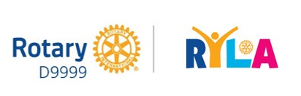
Thank you for supporting local current and future Leaders.

What does it cost?
Nothing – successful applicants are fully sponsored by a local Rotary club or can be corporate or industry sponsored.
All that applicants are required to provide is 6 days of their time, a positive attitude, an open and engaging mind, and lots of enthusiasm.

Do I qualify?
Yes, if you are aged 20-30 (or 18-25 for RYLA CHCH), have the desire to be a leader of the future, have the will to invest in your own growth and have the passion to be the best you can. There is some physical activity, but equally, we encourage applications from persons with physical difficulty who are self-sufficient.

What’s in it for me?
This course will benefit you if your intention is to:
- Grow and develop as a leader
- Discover and develop your own personal skills and strengths
- Challenge yourself physically and mentally to extend your capabilities
- Interact with and learn from inspirational business and community leaders
- Network with like-minded individuals from varying backgrounds
- Advance your ability to operate and communicate effectively in a team environment

What can I expect?
Every day is different. There will be inspirational and informational speakers every day, group discussions, fun & games, team challenges, physical activities, off-site visits, and a community project that you will work on as a team.
You will probably discover things about yourself that you did not know. The other RYLArians will be a diverse and interesting group of people and you will make life-long friends with many, if not all of them. You will also make important and valuable connections and networks. RYLA is something that you will remember for many years to come.

Where is RYLA held?
You can choose between 2 Camps – depending on your location, age or the dates that suit you best. Watch the videos below
- RYLA Queenstown held at Lakeland Park Camp, Kelvin Heights
VIDEO’S - https://youtu.be/Adlb2FMLfkc and https://fb.watch/ew0uV8WwtH/
CONTACT: d9980rylaqt@gmail.com or web: www.D9999RylaQt.org.nz
- Or RYLA Christchurch is held at College House, Christchurch
VIDEO - https://vimeo.com/252842997
CONTACT: d999rylachch@gmail.com or web: www.D9999RylaChch.org.nz

Both camps have comfortable and modern facilities and secure off-street parking.
See you there!

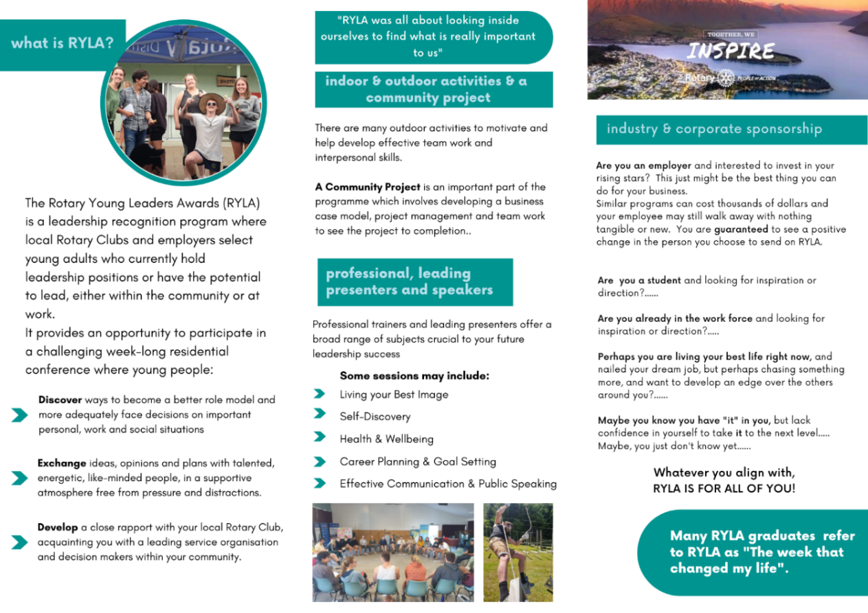
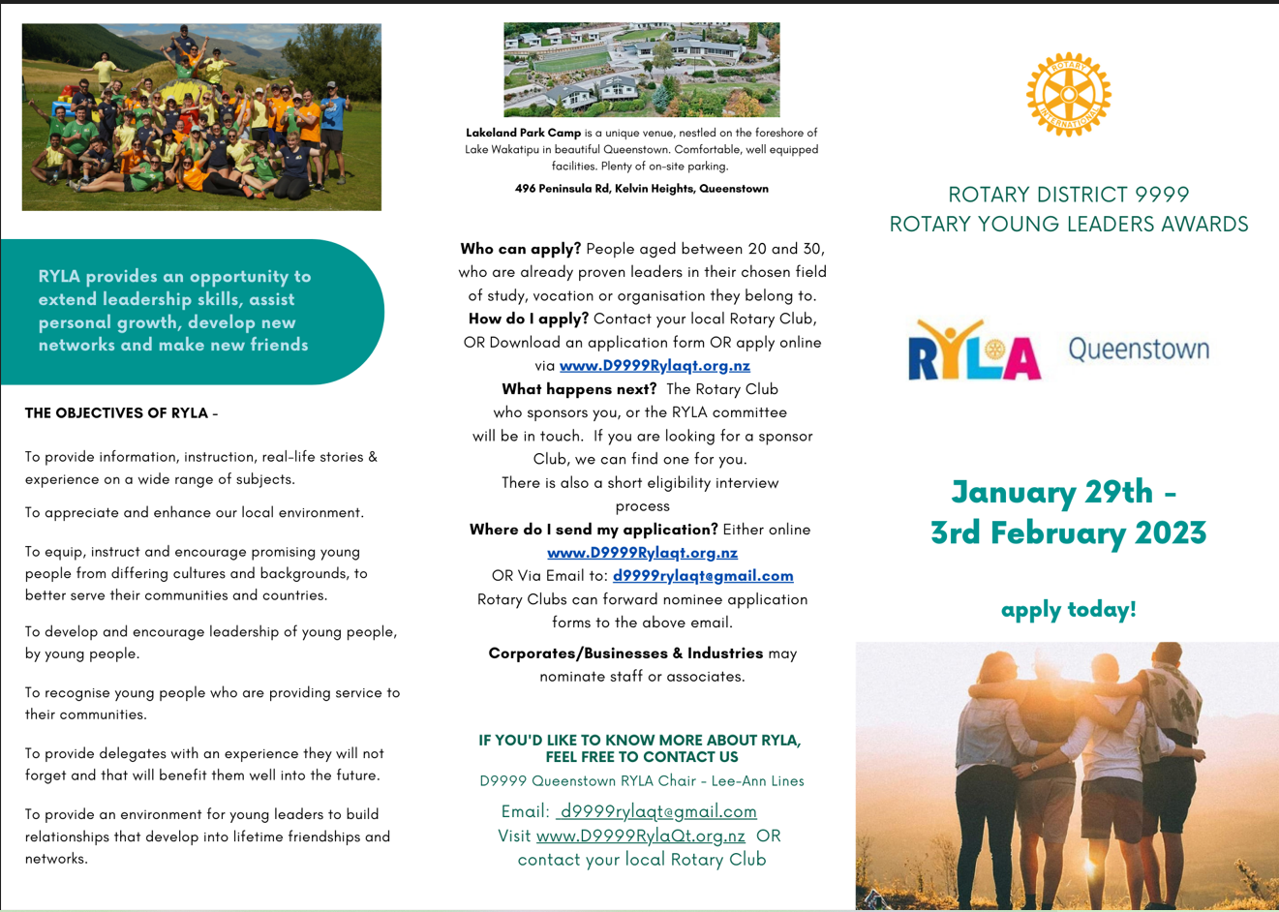

FOR THE NOMINEE TO READ AND SIGN. PLEASE RETURN WITH APPLICATION FORM.
By accepting a spot on to the RYLA programme the participant acknowledges they have read the accompanying Code 0f Conduct and they agree to the following terms:
I confirm that
- I am enrolling for a Rotary Young Leader Award programme (RYLA) and I will participate fully in the programme.
- All information given by me is true and correct
- I will be available to attend for the duration of the entire programme from -
Sunday, 29th January 2023 – Friday, 3rd February 2023
- I am able to get myself to and from the Queenstown venue on the dates above.
- I will follow the instructions of the RYLA Organising Committee including health and safety requirements.
- I will follow the camp rules and agree to the RYLA Code of Conduct.
- In the event of my failure to follow the camp rules and Code of Conduct, I may be returned to my home at the first available opportunity at my own expense.
- In the event of a personal medical emergency or if I require any medical assistance, I agree to reimburse the D9999 RYLA Committee any expenses my treatment or care may occur, upon invoice.
- I understand my sponsoring Rotary Club or Corporate has invested in my attendance and my leadership development, and that they have committed to paying for me. If I withdraw without significant warning and I was not able to find a suitable replacement or if I do not complete the programme, the sponsor may choose to recover costs.
- I agree that any photographs taken of me during RYLA may be used for the purposes of promoting RYLA.
- I agree to my name, contact details and photograph being used on a list of participants for RYLA follow up, RYLA Alumni and administration purposes.

NAME: ……………………………………………………………………………………………………………………….

SIGNED: ………………………………………………………………………..

DATE: …………………………………………………………………………..

This Form is to be returned with Application Form

PLEASE NOTE: The application form and this signed Terms of Agreement Form are to be emailed to: d9999rylaqt@gmail.com no later than December 1st, 2022. Late applications may be accepted if maximum course numbers have not been reached.

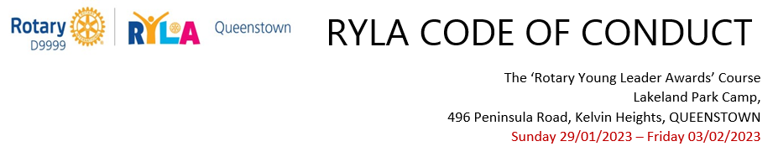
This is for the Applicant to keep

- Participants will treat the (VENUE) Camp staff, the camp buildings and facilities and the environs with courtesy and respect at all times.

- Participants will treat each other, volunteers and Rotarians with courtesy and respect at all times.

- Participants must keep noise to a minimum after 10pm and before 7am. It is advised that you heed the lights out at 11pm suggestion. You will need your rest.

- Participants are not permitted to leave the Campgrounds without permission. If you do need to go somewhere, you must first ask for permission from a committee member on site, the Camp Mum/Dad or your Team Leader. Under no circumstances is ANYONE permitted to go to the Boat Ramp/Jetty below the camp at any time without permission and is strictly forbidden at night.
(This is a requirement of the Camp H&S Policy and also in consideration for the residents).

- Participants are expected to take full part in the camp programme and attend all sessions.

- We aim for total engagement in the programme and with your fellow RYLArians with no distractions and therefore ask that you keep cell phone use to a minimum. You must respect guest speakers during their sessions at all times and not use your cell phone, unless taking a photo or is a requirement as part of the session.

- There will be no sexual liaisons during the camp week.

- Under no circumstances are drugs and alcohol permitted.

- Please smoke or Vape in the designated areas only or go off site. Please let a committee member, or your Team Leader know if you intend to do this.

Administration of the Code
- All breeches of the Code of Conduct will be acted upon immediately.

- All parties involved will have the right to be heard, and to have representation.

- A major breech of the Code of Conduct will result in the participant being sent home at their own cost.

Please ensure all items are clearly NAMED. The RYLA Committee or the venue managers accept no responsibility for any loss or damage that may occur while you are on the course.

General use throughout the week:
- Pillow and sleeping bag or duvet cover
- Single fitted sheet
- 2 Shower Towels
- Personal toiletries
- A small basic personal first aid kit with pain relief and plasters etc
- Any personal medication can be put in a separate plastic bag (the Camp Nurse can look after these for you or help refrigerate if required)
- Swimming togs and beach towel
- Casual comfortable clothing for 6 days
- Sports clothing for daily exercise (may get wet or dirty)
- Casual footwear for day to day, walking and sporting use
- Formal / semi-formal wear for one social evening (Award Gala Dinner Event)
- Sunhat and Sunscreen
- Camera if you wish
- Musical instruments if you wish
- Photo ID
- Laptop and mobile phone optional
- Face Masks

Please also Bring: 3-5 non-perishable, in date, food items for a charity grocery hamper 😊

DO NOT BRING:
Anything Valuable
Alcohol or Drugs

Extra Outdoor Equipment:
Waterproof Jacket (over pants are optional)
Polar Fleece over layer
1 thermal layer
Beanie and woolen socks (optional)
Small day back-pack. Drink Bottle
Head torch (preferable) or standard torch

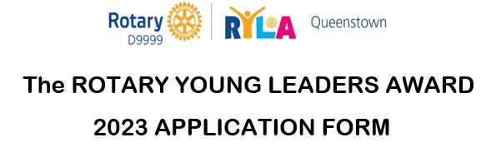

- Candidate completes sections 1 to 8

- Corporates complete section 9 (Clubs can also do this on behalf)
- Rotary Club completes section 10
- Applications open on 1 July 2022. This form can be completed either on-line or by being printed and handwritten. Please email back to d9999rylaqt@gmail.com no later than November 20th, 2022. Late applications may be accepted if maximum numbers have not been reached.
- All personal information will be kept confidential except when disclosure is required for your health or wellbeing, e.g. the caterers for any dietary or food allergy requirements. Please be honest with your responses so we are aware of, and able to properly respond to any incidents that may occur. Thank you.

COURSE ATTENDING: PLEASE TICK RYLAQT or RYLACHCH

PLEASE PRINT CLEARLY

- PERSONAL DETAILS
Surname
Given Name
Preferred Name
Address
Address 2
Town / City
Mobile Phone
Business Phone
Email Address
Date of birth (dd/mm/yyyy)
Sex (M/F/Other)
Shirt Size (S/M/L/XL) | (Sizing is what you normally wear)

2. EMERGENCY CONTACT
(CAN BE A FAMILY MEMBER, PARTNER, OR NOMINATED ROTARIAN)

Contact Name
Relationship
Address
Address 2
Town / City
Home Phone
Business Phone
Mobile Phone
Email Address

3. HEALTH if completing online, this section must be fully completed. If completing during a Rotary club interview, you may choose to leave this section and answer during the final interview with the RYLA Committee member handling your application.
For the safety of all candidates, all medication must be disclosed to the RYLA Organising Committee and third-party providers relevant to the programme. Any information disclosed will not affect your acceptance onto the course

Any Health Conditions or Concerns

Current Medication

Dietary Requirements AND/OR Allergies
Is there anything we need to be aware of? (ie triggers, phobias, fears)

- EDUCATION

School/Tech/University

Courses Taken
Or Degrees Obtained
Year Currently in or final Year Attended
Special Awards or Recognitions

- OCCUPATION

Current employer
Position held
Period of employment
Position held
Period of employment
Do you need to ask for time off?

- RECREATIONAL INTERESTS & INVOLVEMENT

Sporting

Organisation / Clubs

Hobbies

Community Volunteering groups

- NOMINEES QUESTIONS

Are you able to bring all the necessary equipment?
Describe your level of fitness:
1 -5 (5 being awesome)
You will be sponsored into this leadership programme. Why do you think you are a worthy candidate?
Who will be paying for you to  attend RYLA….. Please circle one  - Yourself  - Rotary Club  - Employer or Corporate  - I am looking for a sponsor  - Other: | I understand that I may be asked to speak to the Rotary Club who nominated me.

- DECLARATION
__________________________________________________________________________

I, being the Applicant,
- understand that I will be required to abide by the Code of Conduct and adhere to all the requirements and instructions of the staff at RYLA during my participation in the programme and that in the event of my failure to do so in a reasonable manner I may be returned to my home by the first available transport, with any additional costs so incurred being paid by myself, parents, or guardian.
- (Please include any comments if you have any, here)

………………………………………………………………………………………………………………………………
- in accordance with the Privacy Act, agree to my name and contact details being used on a list of awardees for RYLA follow-up, administration, and Alumni list.
- Authorise the RYLA Queenstown Operational Committee to use appropriate photos of myself in future presentations or publicity of the RYLA event.
- Authorise the Chairperson & the RYLA Queenstown Operational Committee, where it is impractical to communicate with me, or to secure my prior consent, to give consent on my behalf to any medical or surgical treatment as may be necessary for my wellbeing and I undertake to meet such cost incurred.
- will email a head and shoulders passport style photo in .jpg or similar format along with this application.

Signed: ………………………………………………………………. Date: …………………………………………….

- EMPLOYER OR CORPORATE SPONSORSHIP USE
Name of Business/Corporation
Name of Sponsor/Contact
Mobile Phone
Other Phone
Email
Position
The corporate contact is aware the course fee is $900pp (GST exempt) | YES – Please provide invoice to the contact and email above  NO – Please make contact or provide more information

10. NOMINATING ROTARY CLUB USE

The Rotary Club of ……………………………………………………………… recommends and endorses this Applicant be selected for the RYLA Queenstown 2023 Programme.

Rotarian Contact Name
Date
Rotarian Mobile Phone
Email
Position in Club

NOTES FOR NOMINATING ROTARY CLUB or CORPORATE SPONSOR
- Clubs are required to endorse any corporate sponsored nominees.
- Clubs are to use the correct forms and are responsible for interviewing, completing, and submitting the appropriate paperwork including a head shot photo of applicant.
- Corporate sponsors can submit an application form on behalf of their nominated staff member.
- Final selection of candidates remains with the RYLA Queenstown Operational Committee.
- Completed forms are to be emailed to d9999rylaqt@gmail.com by 20th November 2022. Late registrations will be accepted if maximum course numbers have not been reached.
- The application fee per awardee is $900 (GST exempt). Cheques are not accepted. Please advise if you require a receipt.
Email address to send receipt to is : ………………………………………………………………………………..
Please make your payment by direct credit via internet banking to:

QUEENSTOWN RYLA CAMP - 01-0635-0320139-01

Be sure to note your Club’s name in the Reference Box
Please remember to include the signed Terms of Acceptance with this form

(or if you are sending your candidate to the Christchurch Camp, please use
account # – 01-0635-0320139-02)

Thank you for supporting RYLA and our Future Leaders

